PREPARED by: MALINDA KUMARASINGHE

MALINDAKPT@GMAIL.COM

0771141194

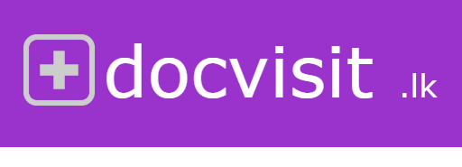

Project Communication Plan

INTRODUCING DOCVISIT.LK

Version 1.0

November 10, 2016

## WHAT IS DOCVISIT.LK

This is a website developed for saving the time of patients who comes to consult, specialist doctors in channeling centers.

## PROBLEM SCENARIO

Both doctors and channeling center managers cannot predict the arriving time of a doctor to specific channeling center. Sometimes patients have to wait 2 or 3 hours until doctor comes there and his number calls. There are several reasons for this.

1. Doctors have to travel from channeling center to channeling center by their own vehicles. So road traffic may affect for the arrival time
2. Number of patients in a channeling center may vary from day to day and place to place. So the time, spending in a specific channeling center cannot be guessed.
3. Time to examine a patient also may depends on patient’s disease, symptoms of the patient, type of the doctor and many more factors.

Because of this unpredictability, patients have to come to channeling center early and waste their valuable time there until doctor comes there.

The only thing that patients can do is, calling channeling center frequently and ask the status from them. It’s really annoying for both channeling center and the patient.

Waiting inside the channeling center alone (sometimes without a seat) is a very boring thing for any person. What they need is, stay with their family members at home and come to channeling center on the moment of their number calls.

## SOLUTION

Now all most all the people have a smart phone with them. So they can access docvisit.lk application online.

* Then patients can see whether doctor has arrived to the channeling center or not through docvisit.lk.
* Not only that, they can view the current examining patient number through this application.

There is no need of patients to come channeling center early. As an example, if a patient’s number is 26 and current channeling number is 2, he is not needed to stay at channeling center from number 2 to number 25.

1. He can go to a shopping center near by channeling center,
2. Go to food court with his family members
3. Stay in his own vehicle until his number calls (If they feel more comfortable).
4. Stay at their home until it reaches their number.

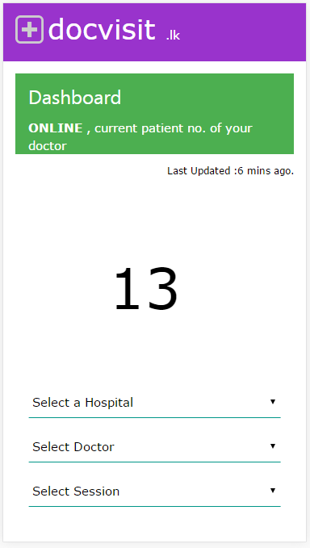

Select the channeling center/hospital and doc tor name and time slot/session for your booking

Current patient number is shown here, and it updates automatically

## ADVANTAGES TO CAHNNELING CENTER

By this patients can save lots of their valuable time. And the channeling center also get lots of advantages from this.

1. Reduce the number of calls to receptionist’s phone asking whether doctor has arrived and what’s the ongoing number.
2. Here after only small number of patients wait inside the channeling center. So, although you have limited number of seats, you can channel more patients in a single session as space requirement may reduce after this.
3. Also you can reduce air conditioning cost in channeling time at lobby area (lesser number of patients inside).
4. Parking space problems will not occur as patients don’t come early and wait.

They will come to channeling center on right time.

1. **\*\*\*\*\*\*\*\*\*\*\*\*\*\*\*\*\*\*\*\*\*\*\*\*\*\*The most attractive advantage here is, When a patient get to know that your channeling center have docvisit.lk facility, He will definitely come to your place by passing other channeling centers as the most valuable resource for them is the time. At the next day, first question they ask from the channeling center may be,**

**Do you have docvisit.lk facility for channeling doctors?**

*For this to happen, there is one thing to be done from your channeling center.*

Definitely there is a responsible nurse for each doctor to arrange the queue for the doctor. We will give a mobile phone with this application for them.

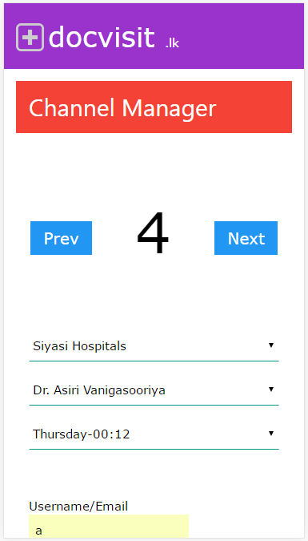

Example: If current patient number is 4 and when she calling to the patient with number 5, she has to press NEXT button of the application. Then all patients will get to know that current number is 5. (This is very simple mobile application and they don’t need any previous experience or knowledge about this to act on this)

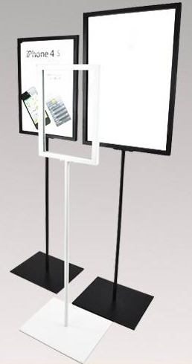

RESPONSIBILITIES

All advertising tasks will be carried out by our team.

1. Radio advertisements
2. TV advertisements
3. Newspaper advertisements
4. Posting help guides in your channeling center

And we will distribute handouts and help guides for motivate/helping patients to use this application for the first time.

All the functionalities of the docvisit.lk are fully automated and it will updates all the patients on correct time and accurate manner.